

**UNIVERSITY OF PETROLEUM & ENERGY STUDIES**

**Dehradun**

**CONTINOUS INTEGRATION**

**AND**

**CONTINOUS DELIVERY**

**Containerization Lab**

**Name: Madhav Bhatia**

**Course: B. TECH CSE DevOps (2018-22)**

**Roll no.: R171218061**

**Sapid: 500068227**

**Experiment-12**

**Containerization Lab-2**

**Step-1:** Install the docker using following steps

* First, in order to ensure the downloads are valid, add the GPG key for the official Docker repository to your system:  
  $ curl -fsSL https://download.docker.com/linux/ubuntu/gpg | sudo apt-key add –

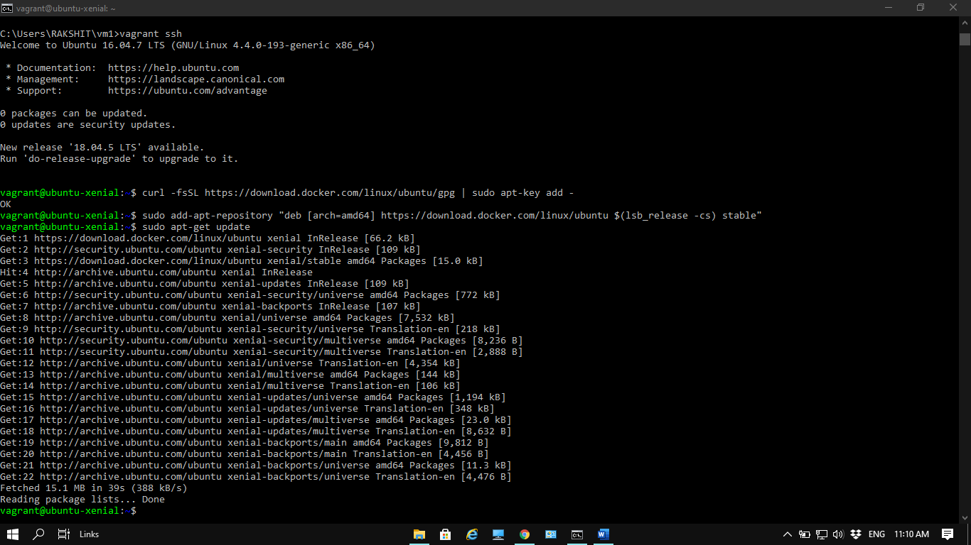

* Add the Docker repository to APT sources:

$ sudo add-apt-repository "deb [arch=amd64] https://download.docker.com/linux/ubuntu $(lsb_release -cs) stable"

* Next, update the package database with the Docker packages from the newly added repo:

$ sudo apt-get update



* Make sure you are about to install from the Docker repo instead of the default Ubuntu 16.04 repo:

$ apt-cache policy docker-ce

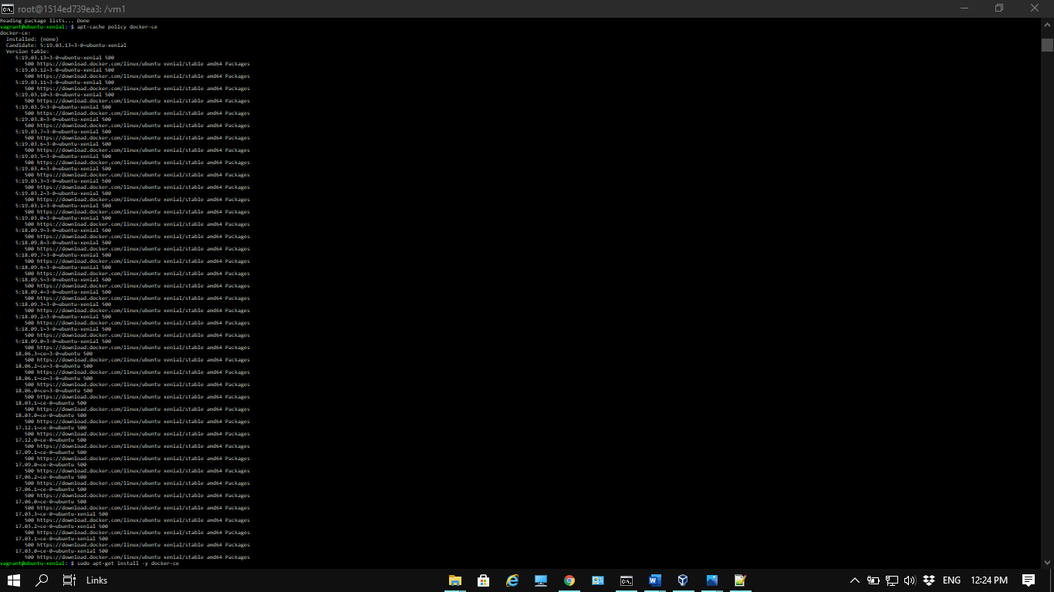

* Finally, install Docker:  
  $ sudo apt-get install -y docker-ce

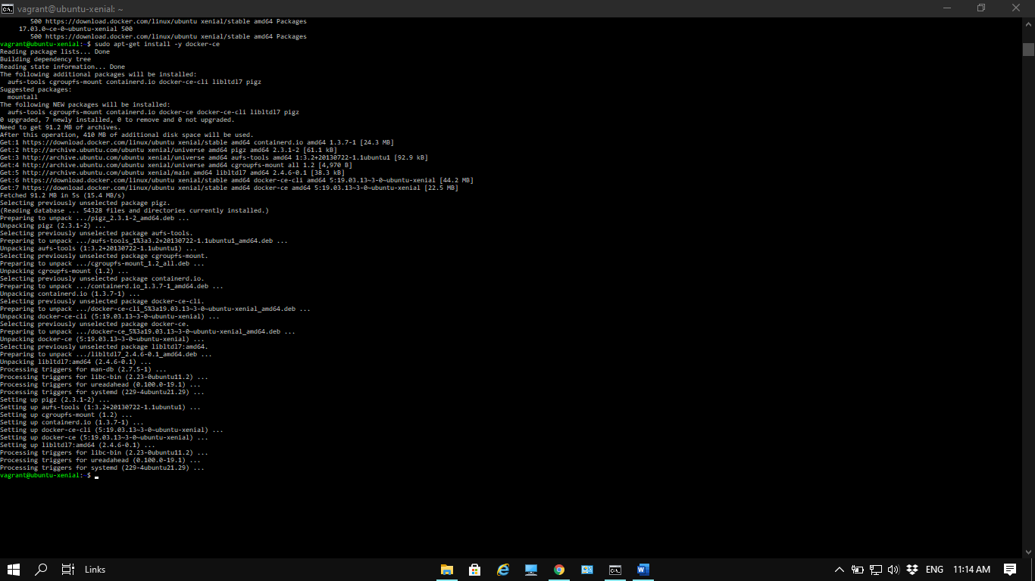

**Step-2:** Executing the Docker Command Without Sudo

* If you want to avoid typing sudo whenever you run the docker command, add your username to the docker group:

$ sudo usermod -aG docker ${USER}

* To apply the new group membership, you can log out of the server and back in, or you can type the following:

$ su - ${USER}  
You will be prompted to enter your user’s password to continue. Afterwards, you can confirm that your user is now added to the docker group by typing:

* If you need to add a user to the docker group that you’re not logged in as, declare that username explicitly using:

$ sudo usermod -aG docker username

* Check the version of the docker

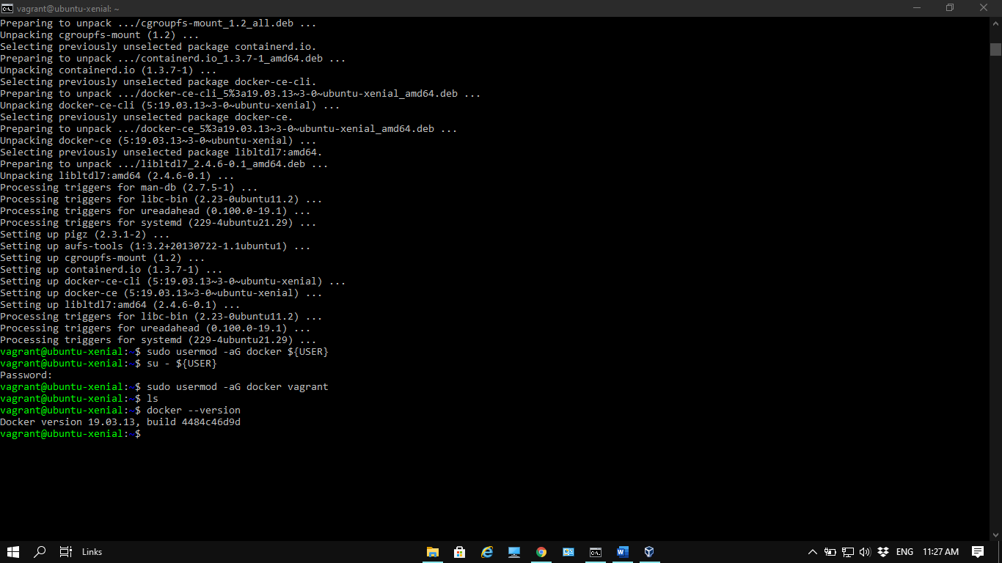

**Step-3:** Type **docker run -it ubuntu.** Create a new directory in ubuntu docker container and list the directory using command line**.**

